

Section: Doctrine of the Church (Ecclesiology)

Teacher: Joshua Kirstine

February 19, 2025

**HANDOUT NOTES**

**Proverbs 13:24** Whoever spares the rod hates his son, but he who loves him is diligent to discipline him.

**Luke 9:23** … “If anyone would come after me, let him deny himself and take up his cross daily and follow me.

Our topic tonight is by no means a popular one in our “to-each-his-own” culture. Sadly, as biblically grounded and clear as this is in God’s word, many churches/Christians out right disobey the Lord and do not practice these things.  It’s my prayer that we lean in and embrace the practice of these important commands of our Lord.

It needs to be understood that our scope in this lesson is regarding our relationships that Christians have with others who proclaim faith in Christ.

**Q106. What is Christian accountability and discipline?**

It is loving correction to someone who professes to be a Christian when he/she is out of step of core sound doctrine or practicing other sin. If he/she does not repent after biblical efforts are made, then God’s instruction is dis-fellowship until he/she does. All Christians are to joyfully submit to biblically-based accountability.

**Q107. Why do we do Christian accountability and discipline?**

We practice Christian accountability and discipline because of our love for God and our love for one another.  It glorifies God when we trust and obey His commanded will, and it is loving to others to treat them the way God has ordained.

* **Practicing Christian Accountability and Discipline is a Blessing**

**Proverbs 27:6** Faithful are the wounds of a friend; profuse are the kisses of an enemy.

**Proverbs 15:32** Whoever ignores instruction despises himself, but he who listens to reproof gains intelligence.

**Ecclesiastes 7:5** It is better for a man to hear the rebuke of the wise than to hear the song of fools.

**Hebrews 12:11** For the moment all discipline seems painful rather than pleasant, but later it yields the peaceful fruit of righteousness to those who have been trained by it.

* **Ignoring or Avoiding Christian Accountability and Discipline is a Curse**

**Proverbs 26:12** Do you see a man who is wise in his own eyes? There is more hope for a fool than for him.

**Proverbs 5:22-23** The iniquities of the wicked ensnare [a person], and he is held fast in the cords of his sin. He dies for lack of discipline, and because of his great folly he is led astray.

**Revelation 2:4-5** But I have this against you, that you have abandoned the love you had at first. Remember therefore from where you have fallen; repent, and do the works you did at first. If not, I will come to you and remove your lampstand from its place, unless you repent.

**Romans 12:9** Let love be genuine. Abhor what is evil; hold fast to what is good.

We practice Christian accountability and discipline because of our love for God and our love for one another.  It glorifies God when we trust and obey His commanded will, and it is loving to others to treat them the way God has ordained.

* **The Bible’s Commands for Christian Accountability and Discipline**
* Go and tell him his fault, between you and him alone

**Matthew 18:15** “If your brother sins against you, go and tell him his fault, between you and him alone. If he listens to you, you have gained your brother.”

**Ephesians 4:3** [Be] eager to maintain the unity of the Spirit in the bond of peace.

* If he does not listen, take others along with you

**Matthew 18:16** “But if he does not listen, take one or two others along with you, that every charge may be established by the evidence of two or three witnesses.”

**Matthew 18:17** If he refuses to listen to them, tell it to the church. And if he refuses to listen even to the church, let him be to you as a Gentile and a tax collector.

**Hebrews 13:17** Obey your leaders and submit to them; for they are keeping watch over your souls, as those who will have to give account. Let them do this with joy and not with groaning, for that would be of no advantage to you.

* If he refuses to listen to the elders/Church: dis-fellowship

**Matthew 18:17**

*Christians need to honor God in this*.

-Here, your elders are committed to it—you’ve heard and seen these things from us.

-Your membership covenant agrees to it.

-The church’s, statement of beliefs (publicly published and locally agreed to) clearly declares it.

* Accountability and Dis-fellowship in the Old Testament

**Deuteronomy 13:9** … “Your hand shall be first against him to put him to death, and afterward the hand of all the people.”

**Deuteronomy 17:7** “The hand of the witnesses shall be first against him to put him to death, and afterward the hand of all the people. So, you shall purge the evil from your midst.”

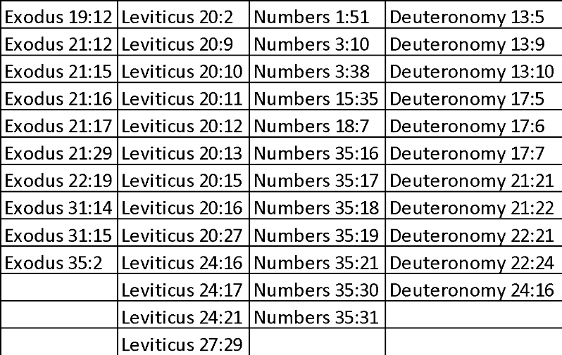

* Christian Accountability and Dis-fellowship in the New Testament

**1 Corinthians 5:1-2** It is actually reported that there is sexual immorality among you, and of a kind that is not tolerated even among pagans, for a man has his father's wife. And you are arrogant! Ought you not rather to mourn? Let him who has done this be removed from among you.

**1 Corinthians 5:3-5**For though absent in body, I am present in spirit; and as if present, I have already pronounced judgment on the one who did such a thing. When you are assembled in the name of the Lord Jesus and my spirit is present, with the power of our Lord Jesus, you are to deliver this man to Satan for the destruction of the flesh, so that his spirit may be saved in the day of the Lord.

**1 Corinthians 5:6-13** Your boasting is not good. Do you not know that a little leaven leavens the whole lump? Cleanse out the old leaven that you may be a new lump, as you really are unleavened. For Christ, our Passover lamb, has been sacrificed. Let us therefore celebrate the festival, not with the old leaven, the leaven of malice and evil, but with the unleavened bread of sincerity and truth. I wrote to you in my letter not to associate with sexually immoral people—not at all meaning the sexually immoral of this world, or the greedy and swindlers, or idolaters, since then you would need to go out of the world. But now I am writing to you not to associate with anyone who bears the name of brother if he is guilty of sexual immorality or greed, or is an idolater, reviler, drunkard, or swindler—not even to eat with such a one. For what have I to do with judging outsiders? Is it not those inside the church whom you are to judge? God judges those outside. “Purge the evil person from among you.”

**Galatians 6:1** Brothers, if anyone is caught in any transgression, you who are spiritual should restore him in a spirit of gentleness. Keep watch on yourself, lest you too be tempted.

**Hebrews 3:13** But exhort one another every day, as long as it is called “today,” that none of you may be hardened by the deceitfulness of sin.

**Titus 3:10-11** As for a person who stirs up division, after warning him once and then twice, have nothing more to do with him, knowing that such a person is warped and sinful; he is self-condemned.

**2 Thessalonians 3:14-15** If anyone does not obey what we say in this letter, take note of that person, and have nothing to do with him, that he may be ashamed. Do not regard him as an enemy, but warn him as a brother.

**Romans 16:17-18** I appeal to you, brothers, to watch out for those who cause divisions and create obstacles contrary to the doctrine that you have been taught; avoid them. For such persons do not serve our Lord Christ, but their own appetites, and by smooth talk and flattery they deceive the hearts of the naive.

**Galatians 1:8-9** But even if we or an angel from heaven should preach to you a gospel contrary to the one we preached to you, let him be accursed. As we have said before, so now I say again: If anyone is preaching to you a gospel contrary to the one you received, let him be accursed.

**2 John 9-11** Everyone who goes on ahead and does not abide in the teaching of Christ, does not have God. Whoever abides in the teaching has both the Father and the Son. If anyone comes to you and does not bring this teaching, do not receive him into your house or give him any greeting, for whoever greets him takes part in his wicked works.

**Matthew 18:15-17** “If your brother sins against you, go and tell him his fault, between you and him alone. If he listens to you, you have gained your brother. But if he does not listen, take one or two others along with you, that every charge may be established by the evidence of two or three witnesses. If he refuses to listen to them, tell it to the church (ekklēsia –that means believers). And if he refuses to listen even to the church (ekklēsias—believers), let him be to you as a Gentile and a tax collector.

* Patience with those struggling but *not* rejecting accountability

**Ephesians 4:1-3**I therefore, a prisoner for the Lord, urge you to walk in a manner worthy of the calling to which you have been called, with all humility and gentleness, with patience, bearing with one another in love, eager to maintain the unity of the Spirit in the bond of peace.

**1 Thessalonians 5:14** And we urge you, brothers, admonish the idle, encourage the fainthearted, help the weak, be patient with them all.

* Seek counsel
* Judge with right judgment

**John 7:24** … "judge with right judgment"

Examples of the kinds of unrepentant sin issues that we are to exercise righteous judgment on for those who claim Christ are:

• unrepentantly persisting in twisting of the gospel (Galatians 1:8-9),

• not acknowledging or teaching sound doctrine as a whole (Rom. 16:17-18; 2 John 9-11; Titus 3:10-11);

• disobeying the commands found in the Bible (2 Thessalonians 3:14-15);

• and sexual immorality, greed, idolatry, slander, drunkenness, and theft (1 Corinthians 5:11).

**Revelation 3:19** Those whom I love, I reprove and discipline, so be zealous and repent.