

Membership Class

Class Session 1

Who We Are & Our Mission

**SERIES OVERVIEW**

**What is the local church?**

The local church is a group of professing believers who have covenanted to unify together to worship and glorify God by fulfilling the commands and mission God has given to the body of Christ.

***Why Covenant Membership?***

*Complete my joy by being of the same mind, having the same love, being in full accord and of one mind.* ***-Philippians 2:2***

*I appeal to you, brothers, by the name of our Lord Jesus Christ, that all of you agree, and that there be no divisions among you, but that you be united in the same mind and the same judgment.* ***-1 Corinthians 1:10***

1. **UNITY:**Covenant Membership provides all members with a clear understanding of the mission, vision, and core teachings of the church body around which they can unify and commit to carry out.
2. **COMMITMENT:**Covenant Membership allows all members to make a commitment to each other that they will fulfill the priorities and expectations according to an agreed upon, written covenant.
3. **ACCOUNTABILITY:**Covenant Membership gives all members a formal avenue by which they commit to the church body and leadership to be held accountable to what God has ordained for His children as they walk daily in Christ.
4. **DEPENDABILITY:**Covenant Membership solidifies who within the local church body can be counted on as dependable members who will use their time, giftedness, and finances to help the church body fulfill its God-given mission, vision, and beliefs.

***Class Objectives:***

To help you understand:

* **OUR STORY**: The history and heritage of Disciples Church and who our pastors are
* **OUR MISSION**: What drives us, our purpose, our vision, and our power
* **OUR TEACHING**: Why theology matters, what we believe in, and what we teach
* **WHAT IT MEANS TO BE A MEMBER**: What you can expect from Disciples’ leadership,

and what is expected from you–the individual members of Disciples Church

***Brief Outline:***

* **Class Session 1: Who We Are and Our Mission**
* Home Session 1: What We Believe (part 1) - DisciplesChurch.com/WhatWeBelieveAudio

* **Class Session 2: Members’ Priorities (part 1)**
* Home Session 2: What We Believe (part 2) - DisciplesChurch.com/WhatWeBelieveAudio
* **Class Session 3: Members’ Priorities (part 2)**
* Home Session 3: What We Believe (part 3) - DisciplesChurch.com/WhatWeBelieveAudio
* **Class Session 4: Elders’ Priorities & The Membership Covenant**

**CLASS SESSION 1: Who We Are and Our Mission**

*I. The Rich and Diverse Heritage of Disciples Church*

**A. Our Story**

*Please see pages 8-10 to read about our 134-year history as a church.

**B. Our Affiliations**

Disciples Church is a self-governing church body that is led by our elders under the authority of the Chief Shepherd, Jesus Christ, and God’s holy Scriptures. We are not governed or controlled by any other organization, denomination, or institution.

Disciples Church has been blessed by the historic and longstanding orthodox teachings of those throughout church history. We identify as a Baptist church in that we stand with the Baptists who framed the historic Baptist Confession of 1689.

**C. Our Leadership**

We believe Jesus is the head of Disciples Church. **Ephesians 5:23** says, “… Christ is the head of the church, his body, and is himself its Savior.” In essence, our leaders’ primary role is to seek God, His holy word, and the moving of His Holy Spirit to faithfully and obediently shepherd His flock.

Scripture calls for local churches to have elders (also called pastors/overseers) who lead the church under Christ and the authority of His word. 1 Peter 5:1-2 says to “the elders among you … be shepherds of God’s flock that is under your care.” Scripture gives us clear instruction as to the qualifications the elders are to meet and what they are to do. God’s word calls for the shepherds of the local flock to protect, feed, lead/manage, and care for the members of the church. Therefore, Disciples Church follows God’s commands in Scripture to have qualified elders lead the church under Christ.

Disciples Church also has faithful staff and volunteers who do their vital part of the work of the ministry.

**Elders**

Joshua Kirstine

Rob Barber

Steve Obert

**Staff Executives**

Joshua Kirstine – Preaching Pastor

Marilyn Stone – Executive Administrator

**Staff**

Justin Ader – Youth Director Jason Nott – Facility Supervisor

Kristen Howard – Administrative Assistant Jeremy Suniga – Music Director

James Miller – Children’s Director

*II. The Unity of Disciples Church – Our MISSION*

**A. What is a mission statement, and why is it important?**

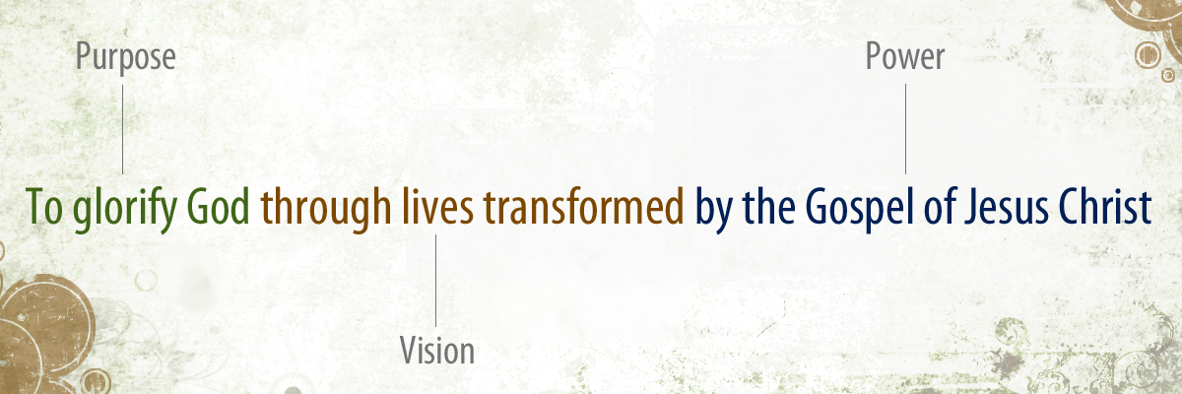**B. Our Mission Statement**

*Please see page 6 for a one-page summary of our mission statement.

**1) Purpose: “To glorify God”**

For from him and through him and to him are all things.

To him be the glory forever. Amen.

**-Romans 11:36**

So, whether you eat or drink, or whatever you do, do all to the glory of God.

**-1 Corinthians 10:31**

**B. Our Mission Statement (cont.)**

**2) Vision: “through lives transformed”**

“I am the vine; you are the branches. Whoever abides in me and I in him, he it is that bears much fruit, for apart from me you can do nothing.” **-John 15:5**

**a) ENJOY God**

*“I am the vine”*

**b) GROW within Community**

*“you are the branches”*

**c) LOVE others**

*“will bear much fruit”*

... speaking the truth in love, we will grow to become in every respect the mature body of him who is the head, that is, Christ. From him the whole body, joined and held together by every supporting ligament, grows and builds itself up in love, as each part does its work.

**-Ephesians 4:15-16**

**B. Our Mission Statement (cont.)**

**3) Power:“by the gospel of Jesus Christ”**

The heart of the gospel--the good news--is the power of God’s glorious grace, which achieves salvation and reconciliation for undeserving and incapable sinners. It is the good news that Jesus Christ, who is God, put on flesh; lived a perfect life; died a sacrificial, substitutionary death; and rose bodily from the grave to secure eternal life for His people.

For I am not ashamed of the gospel, for it is the power of God for the salvation of everyone who believes …

**-Romans 1:16**

1. **Understanding the power of the gospel**
2. IRRELIGION: “I don’t really have to obey anyone but myself.”

ii) WORKS-BASED RELIGION: “I will perform before God to get my right standing.”

iii) THE GOSPEL: “I am redeemed by God--united to Christ eternally--on the basis of the gospel alone by grace through faith; therefore, I obey God.”

On the one hand, the gospel is the truth about God's grace and the “power of God for the salvation of all who believe” (**Romans 1:16**). But on the other hand, this truth is a living power that continually expands its influence in our lives. The gospel is not the first “step” in a stairway of truths; rather, it is more like the “hub” in a “wheel” of truth. The gospel is not just the A-B-C’s; rather, it is the central hub of all of Christianity. The gospel is not just the minimum required doctrine necessary for salvation, but it is also the key to transformation once untied to Christ.

The gospel is not just a truth that we affirm with our minds; it is also a reality we must experience in our hearts and souls. We are transformed when we live “in step with the truth of the gospel” (**Galatians 2:14**)—avoiding both legalism and license—and pursuing the joy found in complete and utter surrender of our unrighteous life in exchange for Jesus’ righteous life (**Galatians 2:20**). The gospel is what makes us right with God (justification), and it is also what frees us to delight in and obey God (sanctification).

The gospel so changes everything about us that it restructures our motivations, our self-understanding, our identity, and our view of the world. The gospel changes our hearts, which then allows everything else about us to be authentically transformed. By thinking, hoping, and living out the “lines” or ramifications of the gospel, every dimension of our lives are renewed: spiritual, psychological, financial, physical, corporate, and social. The gospel is to be applied to every area of thinking, feeling, relating, working, and behaving.

We cannot and need not ever move “beyond” the gospel. This only produces a “different gospel” (**Galatians 1:6–7; 2 Corinthians 11:4; 1 Timothy 1:3**), which is not good news at all. Apart from the gospel of Jesus Christ, there is no forgiveness of sins, no hope, no reconciliation to God, and no transformation into Christ’s likeness.

**

**

“To glorify God”

God has orchestrated human history to display His glory; therefore, the purpose of the Church of Jesus Christ has always been the same. The Church exists to glorify God. Though methods and strategies are always changing to adapt to the shifting culture, the ultimate purpose of the Church has never changed. Because of this truth, our purpose as a local church is first and foremost God-centered: we exist to glorify God. Everything we are and do as a church is designed with the ultimate goal of exalting and glorifying Him above all.

“through lives transformed”

We believe the Bible teaches us that God is most glorified by people who are finding their ultimate joy and satisfaction in Him; however, the default mode of the human heart is to glorify ourselves rather than to glorify God. We believe God is glorified in His saved children when He does the work in us: transforming our lives from that of finding our joy in our own selfishness to that of finding our joy in Him. Said another way, we believe the life that is transformed for God’s glory has three essential pillars:

*ENJOY God*

We believe God is most glorified in us when we are most satisfied in Him. As we are reoriented to the gospel, our hearts are transformed and begin to genuinely find their ultimate satisfaction and joy in God. The result is authentic worship of Him.

*GROW within Community*

We believe life transformation happens best in the context of people doing life and discipleship together, where we can use our gifts to constantly reorient one another back to the beauty and truth of the gospel. The aim is that we are growing in our enjoyment of God and conforming to Christ.

*LOVE others*

We believe as the gospel transforms our lives, it produces sacrificial and loving people on mission, who live to glorify God by growing in Christ and moving beyond themselves to love others with the light and power of the gospel in Bakersfield and the whole world.

“by the gospel of Jesus Christ”

We believe the only way for our lives to be transformed is by the power of the gospel of Jesus Christ. The gospel isn’t a program, but rather it’s the good news about a person, Christ Jesus, that through His death and resurrection, we can be reconciled to God. In other words, we are not accepted by God based on what we do, but instead, we who trust in Christ are accepted by God based on what Jesus did for us. Only the truth of this message has the power to radically transform our lives. As the gospel is understood more deeply, we see the beauty of God more clearly, and our hearts’ affections are then drawn to Him more completely. So as a church, Disciples Church is “gospel centered,” in that everything we do as a church is driven by the gospel and is designed to help us deepen in our understanding and faith in the gospel.

# Our history

**OUR HISTORY**

*Disciples Church was formed in 1889 as the first Baptist church of Bakersfield. The following is a brief insight into our rich history of gospel ministry in the central California valley.*

**THE FIRST BAPTIST CHURCH**

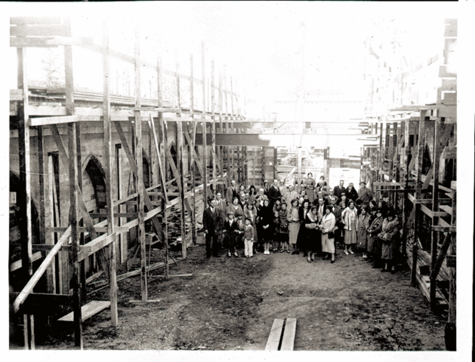Following the discovery of gold in the southcentral California valley, the first pioneers began to settle in the valley in the mid 1800’s. In 1873, the city of Bakersfield was officially incorporated. By the 1880’s the town began to see growth, as the population went from the hundreds to the thousands.

It was in this time that the first Baptist worship services were organized in April of 1889 at George Wear’s Opera House, located at the southeast corner of Eye and Wall Streets, under the shepherding of Pastor J. Campbell Jordan of Fresno. Worship services soon moved to the Kern County Courthouse and remained there until 1890, when the church constructed a permanent building on the northwest corner of 22nd and Eye Streets. In March of 1890, legal requirements were met to incorporate and officially become the “First Baptist Church of Bakersfield.”

**GROWING IN DOWNTOWN BAKERSFIELD**

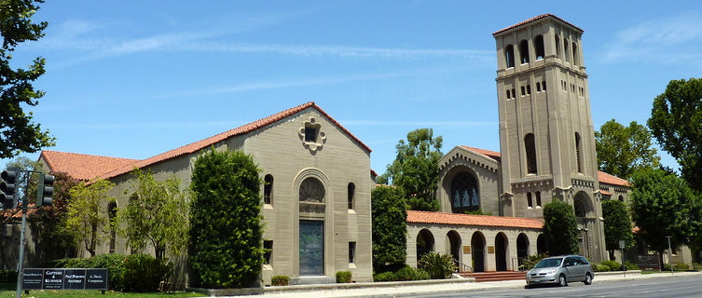In the years to come, the booming Kern River oil fields were attracting workers to Bakersfield. The first few decades of the new century brought with it a great deal of spiritual growth and many challenges. In December of 1924, Frank O. Belden, D.D. of San Diego, California was called to be the next pastor of First Baptist Church. His emphasis on youth activities during this season of ministry brought increasingly larger Sunday school enrollments and growth to the church.

The late 1920’s brought with it the Great Depression, which made for difficulties in shepherding the flock and for building a new church on a property located in the heart of downtown on Truxtun Avenue. However, God provided, and by November 1932, the new church was dedicated and with it, a new season of ministry began. This downtown building still stands today, is distinguished as one of the Bakersfield’s historic landmarks, and was the only religious structure of its era to survive the 1952 Kern County earthquake that destroyed much of downtown Bakersfield.

Over the next two decades as the church grew, so did the desire to plant churches in other areas of the city. The first group sent was the Edison-Fairfax Baptist Mission in 1948, followed by Chester Avenue Baptist Church in 1949, and then University Baptist Church in 1957.

In September of 1961, the church had about 1700 members and was blessed to see such a far and wide influence of the gospel in the southcentral California valley. It was in this season that John A. Lavender, D.D. of Chicago, Illinois became the next lead pastor of the First Baptist Church.

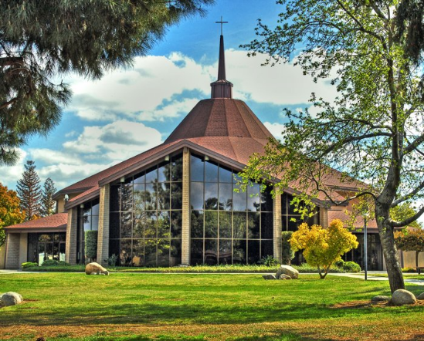

**EXPANDING TO OLIVE DRIVE**

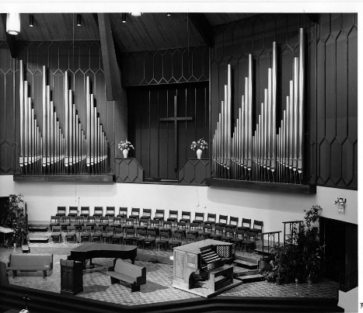The congregation had been outgrowing the church facilities on Truxtun Avenue throughout the 1970’s, so a 32-acre property on the northern outskirts of the city on Olive Drive was acquired. A ground-breaking ceremony for what would be known as the Bakersfield Christian Life Center, home of the First Baptist Church, took place in October of 1977. The campus was designed to house a school and had the privilege of seeing many years of Christian education in addition to church ministry on the large campus, including being home to Bakersfield Christian High School for the years just prior to their building their current campus on Stockdale Hwy. One of the highlights of the large campus was its 1100-seat worship center that would come to be known as Celebration Hall. It housed a famous 8,800-piece pipe organ, which was made up of pipes from the downtown Truxtun church and the Memorial Church at Harvard University. This season of ministry was marked by large music productions and a thriving youth ministry that ministered the gospel of Jesus to 400 students throughout Kern County.

The 80’s, 90’s, and the new century brought many changes in leadership and philosophy of ministry, which equaled significant decline in attendance, especially by those who were longing for more traditional Baptist practice. In 1989, First Baptist Church celebrated its centennial anniversary. In the years to follow, many efforts were made to keep the large campus running.

In 2001, the church changed its name to Olive Drive Church. In 2008, in an effort to bring new life to the aging congregation, a new community within Olive Drive Church was launched with the goal of bringing the gospel to an emerging group of young adults and young families in Bakersfield.

**A NEW ERA OF REFORMATION AND NEW BEGINNINGS**

In 2008, God began a critical work of refinement and rebirth in our church that would become a 10-year dedication to a much-needed biblical reformation of our historic church. It was in this important season that our congregation affirmed that God prepared, qualified, and ordained Joshua Kirstine of Irvine, California to become the next Preaching Pastor. Our conviction to fully submit to and boldly preach God’s word became a driving catalyst to make disciples who make disciples, both locally and worldwide, as we aimed to glorify God through lives transformed by the gospel of Jesus Christ.

In 2014, the church leadership concluded a year-long assessment of the deferred maintenance and demands of the large Olive Drive Campus, and a united conclusion was made that it was time to right-size the church facility by selling the large campus to Valley Baptist Church, allowing us to begin prayerfully looking for where the sixth permanent church facility would be built for the future ministry that God has in store for us.

In this exciting season of transition and transformation, the Lord brought our church family together in a huge way. One of the most critical things God did was to solidify a true plurality of pastoral elders who, together, would faithfully lead our local church forward in the truth of God and for the glory of God.

In 2016, a new property was found and purchased at the corner of Allen Road and Hageman Road in northwest Bakersfield. We broke ground on May 17, 2017, and after just one year of construction, held our dedication ceremony and celebration and first worship services the weekend of June 3, 2018.

The newly named Disciples Church is thankful for God’s endurance of our church for over 134 years and is now enjoying an exciting season, whereby multiple generations of people from all kinds of backgrounds are connecting in authentic relationships, growing in the truth of God’s holy word, and maturing in their faith, as disciples of Jesus are made for His glory here in Bakersfield and to the ends of the earth.

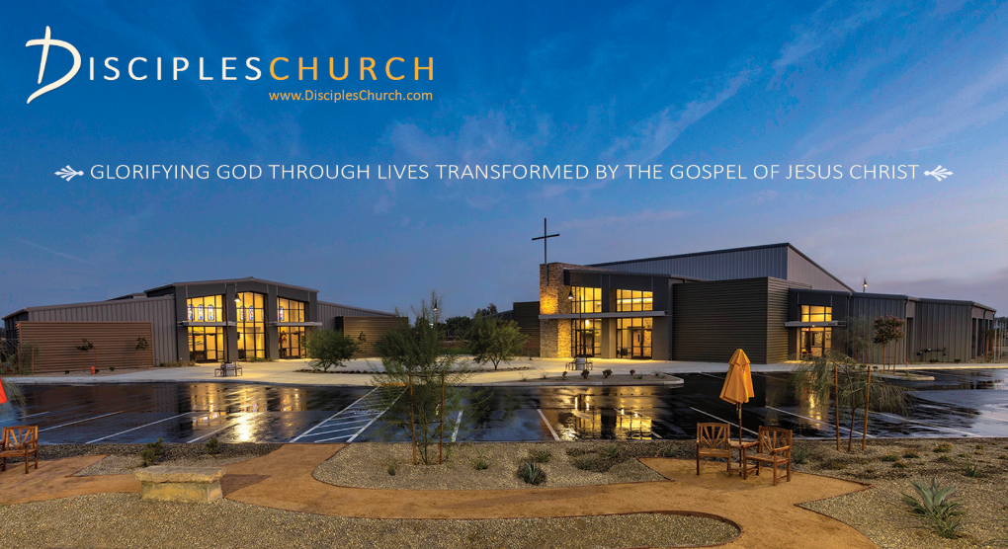

# Our ELDers

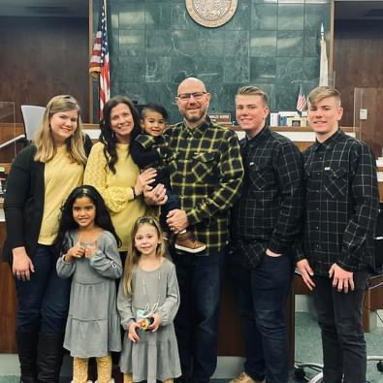**JOSHUA KIRSTINE**

Hometown: Irvine, CA

Vocation: Preaching Pastor at Disciples Church

Wife: Jennifer Anniversary: May 15, 1999

Children: Noah, Parker, Natalie, Piper, Savanna, and Roman

**Contact:**

JK@DisciplesChurch.com

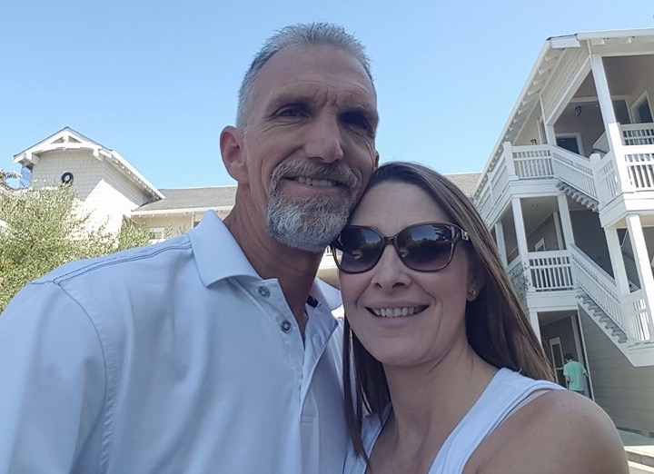

**ROB BARBER**

Hometown: Bakersfield, CA

Vocation: Owner/Operator of Barber’s Quality Lift

Wife: Laurie Anniversary: August 22, 1992

Adult Children: Ashley & Sean, Hannah & Colin, Caleb

**Contact:**

RB@DisciplesChurch.com

**STEVE OBERT**

Hometown: Kern River Valley, CA

Vocation: Engineer at AT&T

Wife: Erin Anniversary: May 25, 2005

Children: Azaria, Arylah, and Ezekiel

**Contact:**

SO@DisciplesChurch.com

# Our STAFF

Administration



**MARILYN STONE**

Hometown: Los Angeles, CA

Title: Executive Administrator

Adult Child: Brock

**Contact:** MS@DisciplesChurch.com

**KRISTEN HOWARD**

Hometown: Phoenix, AZ

Title: Administrative Assistant

Husband: Paul

Child: Jason

**Contact:** KH@DisciplesChurch.com

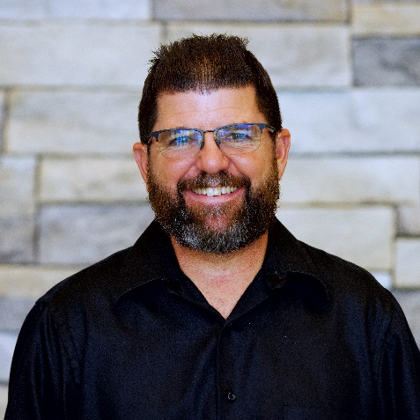**JASON NOTT**

Hometown: Lompoc, CA

Title: Facility Supervisor

Wife: Kelly

Children: Tanner and Tyler

**Contact:** JN@DisciplesChurch.com

# Our STAFF (cont.)

Music

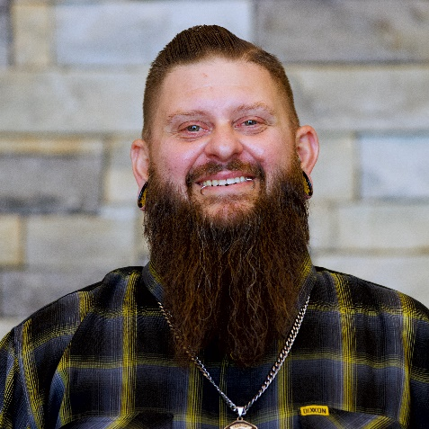

**JEREMY SUNIGA**

Hometown: Bakersfield, CA

Title: Music Director

Wife: Jennifer

Adult Children: Annessa, Brandon, and Tristan

**Contact:** MUSIC@DisciplesChurch.com

Kids/Youth

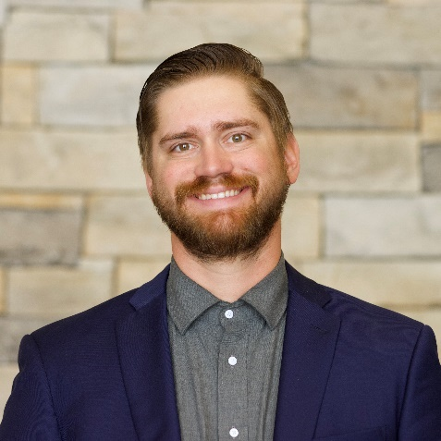

**JAMES MILLER**

Hometown: Bakersfield, CA

Title: Children’s Director

Wife: Veronica

**Contact:** CHILDREN@DisciplesChurch.com

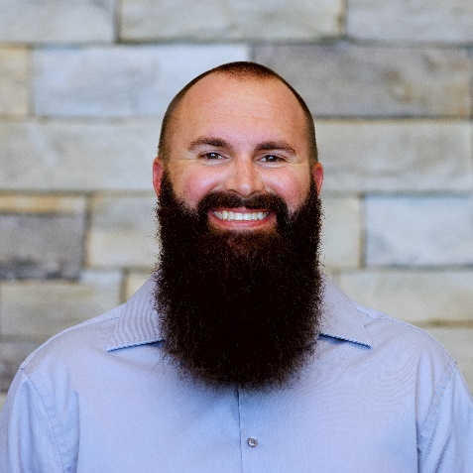

**JUSTIN ADER**

Hometown: Spokane, WA

Title: Youth Director

Wife: Krista

Children: Alexis, Ashley, Emma, John, and Layla

**Contact:** YOUTH@DisciplesChurch.com