

Section: Doctrine of Sin (Hamartiology)

What is Sin (Q33)

Discussion Guide

Q33. What is sin?

Sin is disobeying God; sin is any disobedience in heart or deed to God’s perfect law and commands.

Inherited, Imputed, and Practiced Sin

1. Inherited sin is our sin nature passed down; imputed sin is what is credited to us because Adam was our federal head; and practiced sin is what we do or don’t do in heart, word, or deed that is disobedient to God’s law.

\*Talk about these three as a group to confirm that you understand the differences and how Jesus’ substitutionary atonement on the cross satisfies all three.

Helpful Scriptures: Romans 5:12-21; 1 Corinthians 15:20-22, 45-49

2. Review the list of sins below:

evil thoughts, sexual immorality, theft, murder, adultery, coveting, wickedness,

deceit, sensuality, envy, slander, pride, foolishness, idleness, practicing homosexuality, malice, strife, gossip, hatred of God, haughtiness, disobedience to parents, ruthlessness, orgies, drunkenness, quarreling, jealousy, sorcery, enmity, fits of anger, rivalries, dissension, division, obscene talk

(\*Mark 7:21-22; Rom. 1:24-31; Rom. 13:13; Gal. 5:19-21; 1 Cor 6:9-10; Col 3:5-9; 1 Tim 1:9-10; Rev 21:8)

\*Which practiced sins have you struggled with the most or made light of in the past?

\*How has God’s word and Christ in you helped you to fight those?

\*How are you still making light of some, or not fighting some, and need help?

Passive and Active Sin

3. The sin of commission: the sin of actively doing what God prohibits.

The sin of omission: the sin of failing to do what God requires.

\*How do these clarities of how we sin help you identify and fight your sin?

\*How can you give your group more invitation or permission to journey with you in the areas in which you find yourself struggling?

The Sin of Self-Righteousness

4. Sin is doing the wrong thing (disobedience of God’s perfect law). Sin is also doing the right thing for the wrong reasons (self-salvation or self-righteousness).

\*How have you been guilty doing the right thing for the wrong reasons?

\*Talk about how you can work on these as a group or help each other individually.

Unbelief: The Root of All Sin

Romans 14:23: … For whatever does not proceed from faith is sin.

Hebrews 11:6 (NIV) Without faith it is impossible to please God …

5. Talk about how this truth helps you see just how central faith in God is.

6. Talk about the sobering implications of this for our everyday lives.

7. This truth brings up a huge need for constant gospel reorientation and grounding in His word. How do you implement these more regularly into your life so you truly live by faith?

The Seriousness of Sin:

R.C. Sproul says it well, “Sin is cosmic treason.”

8. We often are guilty of making light of the cosmic treason of which our smallest sin is. Why?

9. Talk about the importance of the Gospel Grid:

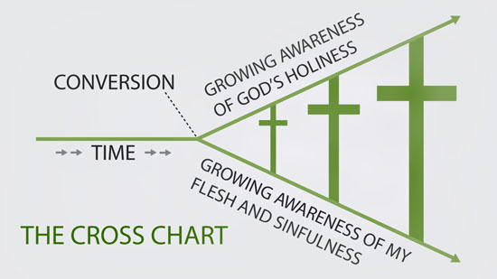

10. Pastor Joshua talked about the temptation to make light of small, everyday sins and/or how we can make too little of big sins once we are headlong into sin. How do we fight these temptations?

Exposing and Avoiding Sin:

11. To close, discuss how the three major tools God has given us to expose and fight sin can be more integrated into your life:

1. The word of God

2. Brothers and sisters in Christ

3. The Holy Spirit