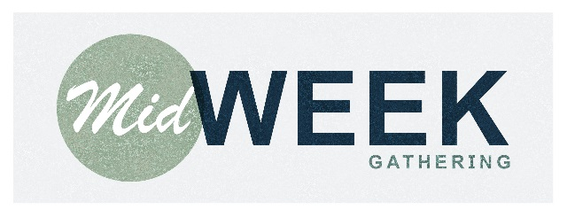

Disciples Church

A Firm Foundation

Creator-Creature Distinction

Week of June 13, 2018

**DISCUSSION GUIDE**

1. What is the Creator-creature distinction?
2. Read Psalm 97:6 & Romans 1:20.
   1. In your personal experience, how has the creation testified of God?
3. Does God submit to the creation?
   1. In what ways do people attempt to make God submit to the creation in how they speak and act?
4. Our culture praises autonomy. What is the danger in thinking that we’re free to think and do whatever we want?
   1. As a Christian, what is our ultimate standard for morality?
   2. What is the non-believer’s ultimate standard for morality?
5. What views do you hold that are currently influenced by secular morality?
   1. How does Scripture shed light on those things? How can we repent and submit to Scripture in these areas?
6. What is relativism? Why is it non-biblical? How has relativism seeped into your own thinking? (Think of popular slogans: live and let live.)
7. Do non-believers know that murder, lying, and stealing are wrong?
   1. Reference Romans 2:15.
8. In order to know something fully, you must know everything exhaustively.
   1. Why is this good news for the Christian?
   2. Why is this bad news for the non-believer?