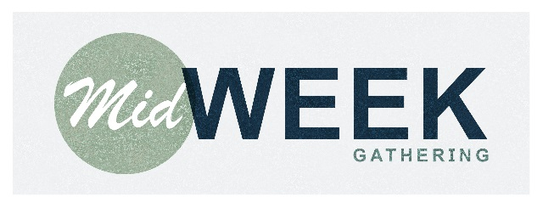

Disciples Church

Marriage & Singleness Series - Session 1 -

Q29. What is Marriage?-Part 1

Week of January 3, 2018

**Handout Notes**

Introduction:

**Q29. What is marriage?**

Marriage is a covenant relationship whereby God joins together one man and one woman into a one-flesh union designed to be faithful and last until the couple is separated by death.

**1. Marriage is God’s Design and Doing**

[Genesis 2:18-25](http://bible.logos.com/passage/esv/Genesis%202.18-25)

**2. Marriage is a Creation Ordinance**

* **It is *perpetual.***
* **It is to be rightly *honored* by all men and women.**

Genesis 2:24; Mark 10:6-9; Ephesians 5:31-32

**3. Marriage is Ordained by God**

Genesis 1:27; Genesis 2:22; Matthew 19:4-6

**4. Marriage is Defined by God**

Genesis 2:24-25

1. **Togetherness:**
2. **Oneness:**

Genesis 2:24

**The Marriage Vow:**

**I take you:**

**To be my wedded wife/husband**:

**To have and to hold:**

**From this day forward**

**For better for worse … For richer, for poorer … In sickness and in health:**

**To love and to cherish:**

**Till death do us part:**

Marriage is a covenant relationship whereby God joins together one man and one woman into a one-flesh union designed to be faithful and last until the couple is separated by death.